**CENWP-OD-B 26 May 2022**

**MEMORANDUM FOR THE RECORD**

**SUBJECT: 22BON011 MFR Unit 15 – Gatewell A Bulkhead Mortalities**

On the afternoon of 25 May, Project Biologists assisted in the removal and fish salvage of Unit 15’s main unit headgate bulklhead in 15A for FGE work. During this fish salvage, 2 smolt salmonid mortalities were discovered. All salvaged live fish were transported downstream to Hamilton Island Boat Launch. No fish were scanned for PIT tags and were returned to the river. Approximately 40 juvenile salmonids were on the bulkhead, approximately 15 were transported, the rest were washed down into the gatewell.

1. Species – Smolt Salmonid (*Oncorhynchus spp*) x2
2. Origin – Unknown
3. Length –
4. Marks and tags –
5. Marks and Injuries found on carcass – none
6. Cause and Time of Death – Removal of U15 A upstream bulkhead, approx. 1400.
7. Future and Preventative Measures – In the future, project fisheries would like to avoid using this bulkhead during peak juvenile passage season. If necessary, the gatewell may be dewatered to the draft tube. Otherwise, a more effective method using nets below each transverse section in the bulkhead to catch fish as the bulkhead comes up and they are hosed out will be utilized.

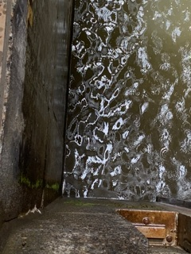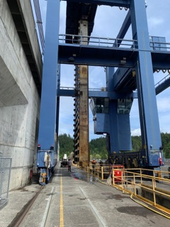

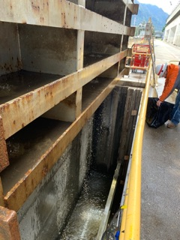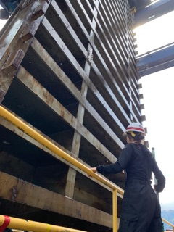

Sincerely,

Bonneville Project Fisheries